Calev Shimon Swabel

NEA ASCII art

AQA GCSE

1.Analysis

This is My Screen Flow Diagram

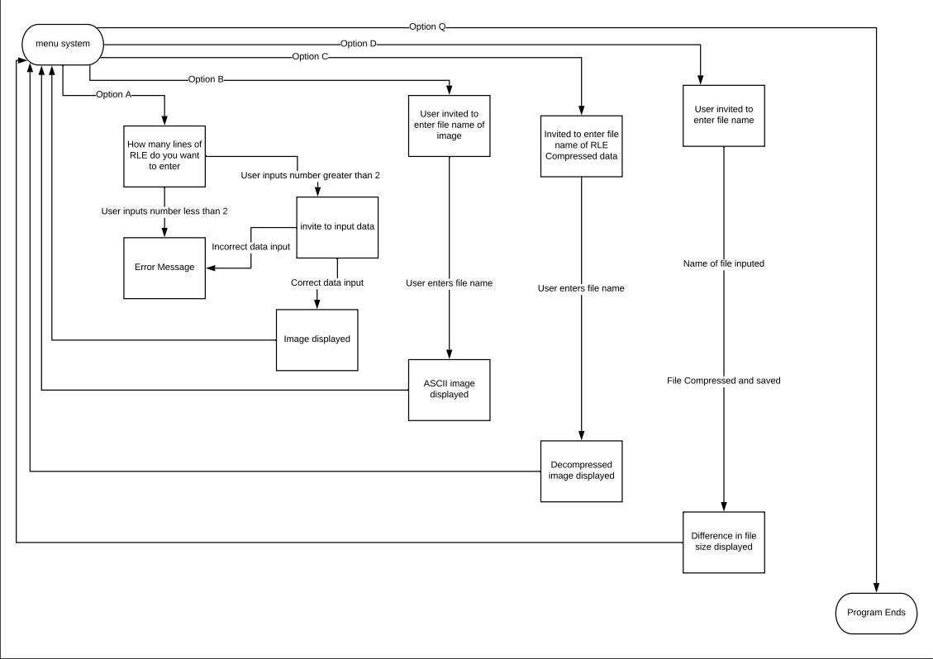

2.Design

Front end

Screenshots of program output

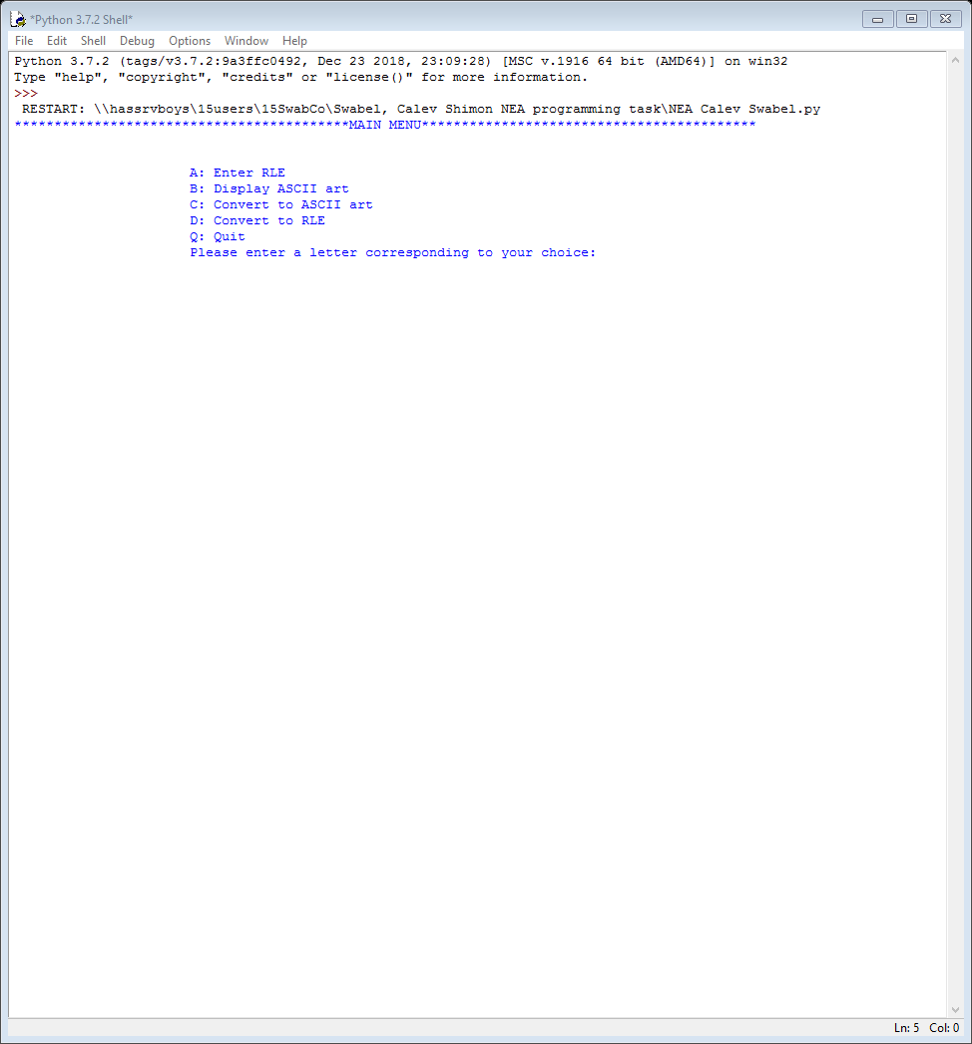

Back end

Flowchart(insert here)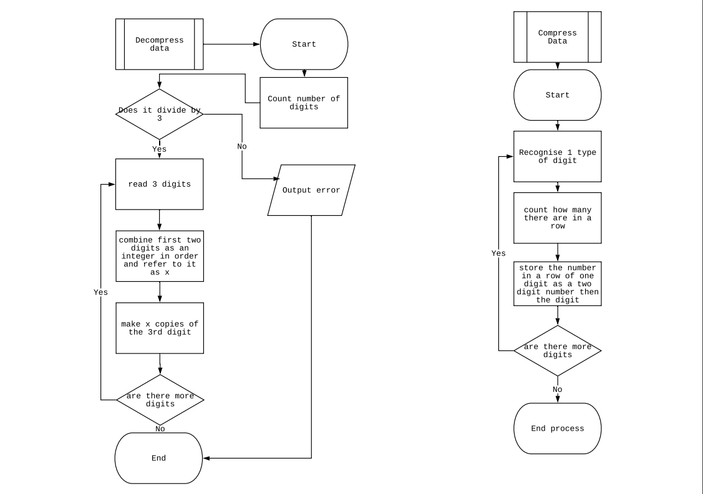

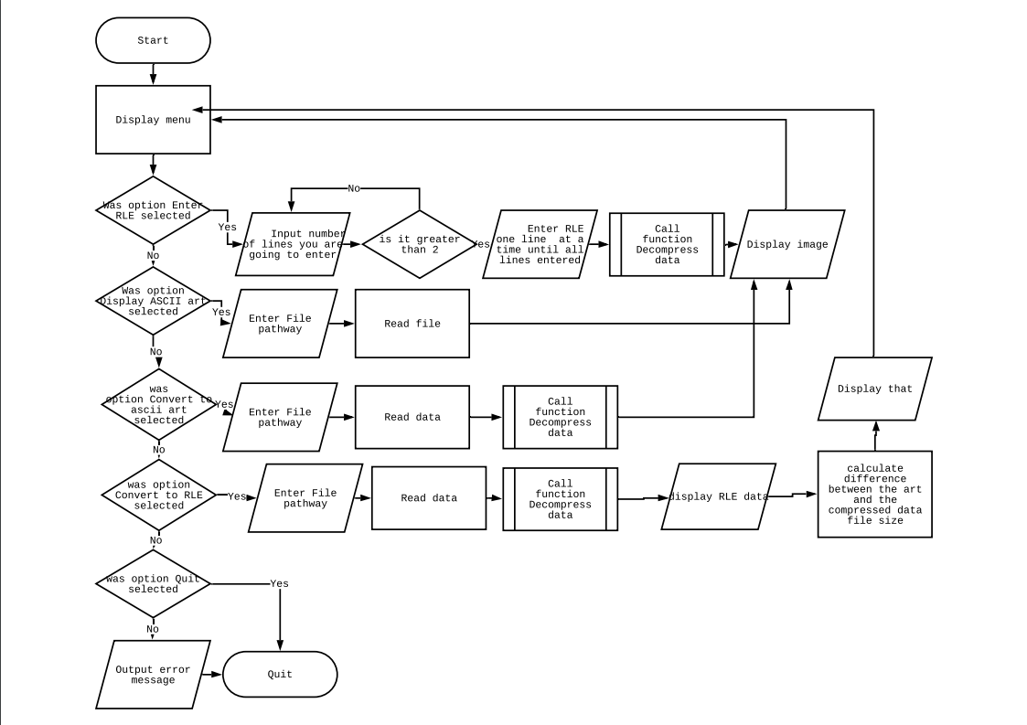

Pseudocode(insert here)

3.implementation

Insert or screenshot of code

4.testing

|  |  |  |  |  |
| --- | --- | --- | --- | --- |
| test | What am I testing | Expected result | Pass/fail | Do I need to change my program? how |
|  |  |  |  |  |
|  |  |  |  |  |
|  |  |  |  |  |
|  |  |  |  |  |
|  |  |  |  |  |
|  |  |  |  |  |
|  |  |  |  |  |

Must include normal, boundary and erroneous data

5.evaluation